

Ingenico Cartridge

Integration documentation

version 20.9.0

Table of Contents

1. Summary 3

2. Component Overview 4

2.1 Functional Overview 4

2.2 Use Cases 4

2.3 Compatibility 4

2.4 Privacy, Payment 4

3. Implementation Guide 5

3.1 Setup 5

3.2 Configuration 5

3.2.1 Services 5

3.2.2 Payment Processors 6

3.2.3 Credit Cards and redirect payment methods 7

3.2.4 Job 7

3.3 Custom Code 8

3.3.1 Display 9

3.3.2 Forms 10

3.3.3 Webhooks 10

4. Operations, Maintenance 11

4.1 Data Storage 11

4.1.1 OrderPaymentInstrument custom properties 11

4.1.2 PaymentTransaction custom properties 11

4.1.3 ServiceCredential custom properties 11

4.1.4 SitePreferences custom properties 11

4.1.5 ingenicoNotification Custom Object 12

4.2 Logs 12

5. User Guide 13

5.1 Business Manager 13

# Summary

The Ingenico LINK cartridge facilitates integration of Salesforce Commerce Cloud with the Ingenico Connect Platform.

This integration guide describes how to integrate the Ingenico payment processor cartridge into the Salesforce Commerce Cloud Storefront Reference Architecture. To this end, this guide shows how to setup and configure the **int_ingenico_sfra** and **bm_ingenico** cartridges, and how to customize your Storefront to make use of the cartridges.

# Component Overview

## Functional Overview

The cartridge supports creditcard, creditcard via hosted payment page, iDEAL, PayPal and Trustly via the Ingenico Connect APIs.

## Use Cases

The cartridge supports the following use cases:

* Consumers can use creditcard, iDEAL, PayPal or Trustly to pay for their purchase
* Credit card, iDEAL, PayPal and Trustly payments can be done with or without an approval.
* Approve payments can be integrated with your Order Manager.
* Cancellations of transactions can be integrated with your Order Manager.

## Compatibility

This cartridge has been available since Salesforce Commerce Cloud version 20.9 (compatibility version 18.10).

It was designed and developed for Storefront Reference Architecture version 4.2.1.

## Privacy, Payment

This cartridge does not process credit card data. As part of a payment, the cartridge does process the customer's billing, shipping and email address as well as the contents of the shopping basket.

# Implementation Guide

## Setup

To use the Ingenico Payment integration you need to install the int_ingenico_sfra and

bm_ingenico cartridges. The ingenico_sfra_changes cartridge contains an example of how your

custom code could work with the Ingenico integration.

To install these cartridges, go to Administration -> Sites -> Manage Sites. Click on the site where you

want to install them and continue on the tab “Settings”. Here you can alter the cartridges path,

include the int_ingenico_sfra and ingenico_sfra_changes before the app_storefront_base but after

your own overlay cartridges. The path should look similar to this:

“your_site_overlay:ingenico_sfra_changes:int_ingenico_sfra:app_storefront_base” .

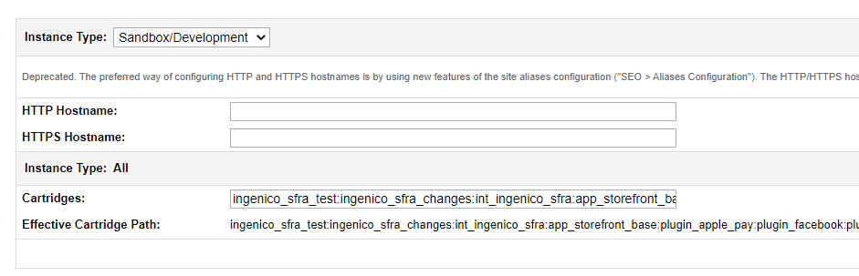

To install the business manager cartridge, return to Administration -> Sites -> Manage Sites and click

on the link under Business Manager Site. Alter the cartridge path as before, make sure to include

bm_ingenico and int_ingenico_sfra before bm_custom_plugin and append app_storefront_base cartridge to the end of the cartridge path like this: “bm_ingenico:int_ingenico_sfra:bm_custom_plugin: app_storefront_base”.

After installing the cartridges, the site import needs to be prepared. Rename the

metadata/site_import/sites/siteId directory to match the siteId you want to install the cartridge for

and create a zip file of the site_import directory.

When the zip file is created go to Administration -> Site Development -> Site Import & Export. Here

you can upload the zip file. To do so, select local and click browse to find the zip file, when selected,

click upload. When the upload is done select the file from the list and select import. You will get an

email when the import job is complete.

## Configuration

There are several locations to configure this cartridge, the site import already creates the payment processor and payment methods for your site.

### 3.2.1 Services

Found under Administration -> Operations -> Services. Here you can find (or create new) services that can be linked on the Payment Processors page. A default IngenicoPayment service is already

created via the site import process.

The Service itself has no specific Ingenico configuration but it is linked to a Service credential that

does.

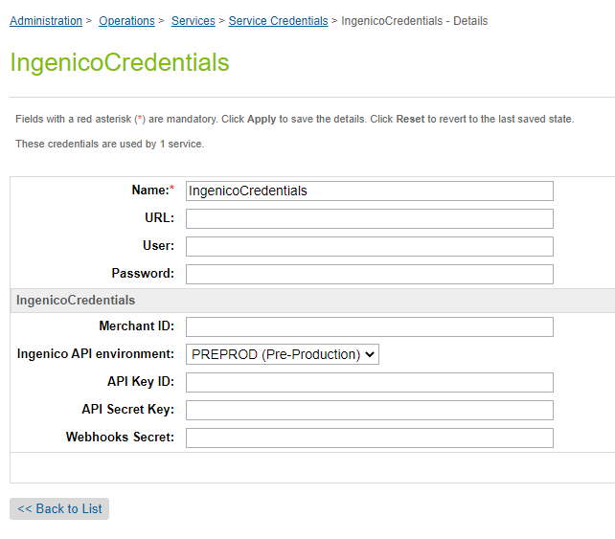

Here you can enter the information needed to access the Ingenico API, the data for these are supplied in the Configuration Center when logging in using your Ingenico account.

Note that the webhooks URL is site-specific: *<your host>/on/demandware.store/Sites-<your site>-Site/default/Ingenico-Notify*

### 3.2.2 Payment Processors

By default, every site uses the same service, if you need sites to use different services you can

configure them to have their own.

Found under Merchant Tools -> Ordering -> Payment Processors. Here you can find the INGENICO

payment processor, click on it to find its configuration under the settings tab.

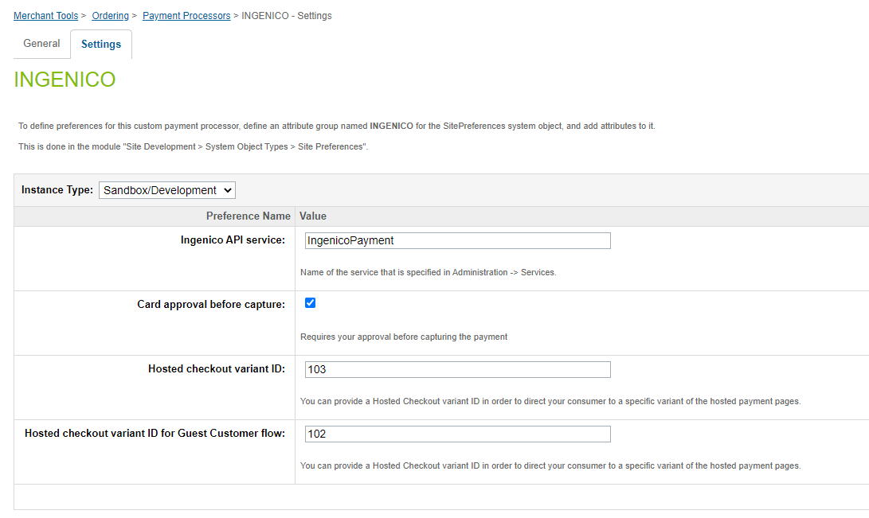

Here you can place the name of the service to use which we will configure next. By default,

IngenicoPayment is selected. This configuration is done here so that different sites can use different

service credentials.

### 3.2.3 Credit Cards and redirect payment methods

In the same location as chapter 3.2.2 you can alter “Card approval before capture” if you prefer payments to be approved before being captured. When approval is needed before capture, you will need to capture the payment yourself, this will be explained in 3.3.5. Finally, you can also provide a Hosted Checkout variant ID in order to direct your consumer to a specific variant of the hosted payment pages.

### 3.2.4 Job

Found under Administration -> Operations -> Jobs. Two jobs, ProcessIngenicoWebhooks and ProcessExpiredOrders, are already created for you, but you do need to assign your site contexts to the job step in order for it to work.

Click on the scope to assign your relevant sites, by default only RefArch is selected you will need to do this for the Ingenico Job.



On the “Schedule and History” tab a recurring interval should already be set.



## Custom Code

An example implementation is supplied in the *ingenico_sfra_changes* cartridge. You can use this in one of two ways:

* Add it to your cartridge path and overwrite where needed
* copying over only what you need from it into your own code.

In this chapter the different alterations in the *ingenico_sfra_changes* cartridge are explained as if you are making these changes in your overlay cartridge.

### 3.3.1 Display

**templates/default/checkout/checkout.isml**

Find the comment saying “Checkout Forms: Shipping, Payment, Coupons, Billing, etc”, below that there is an alert box, replace it with the alert box found in the *ingenico_sfra_changes*.

Copy over the following files:

**templates/default/checkout/billing/paymentOptions/paymentOptionsContent.isml**

**templates/default/checkout/billing/paymentOptions/paymentOptionsSummary.isml**

**templates/default/checkout/billing/paymentOptions/paymentOptionsTabs.isml**

**templates/default/checkout/billing/paymentOptions/creditCardContent.isml**

**templates/default/checkout/billing/paymentOptions/creditCardSummary.isml**

**templates/default/checkout/billing/paymentOptions/creditCardTab.isml**

**templates/default/checkout/billing/paymentOptions/hostedCheckoutContent.isml**

**templates/default/checkout/billing/paymentOptions/hostedCheckoutSummary.isml**

**templates/default/checkout/billing/paymentOptions/hostedCheckoutTab.isml**

**templates/default/checkout/billing/paymentOptions/idealContent.isml**

**templates/default/checkout/billing/paymentOptions/idealSummary.isml**

**templates/default/checkout/billing/paymentOptions/idealTab.isml**

**templates/default/checkout/billing/paymentOptions/trustlyContent.isml**

**templates/default/checkout/billing/paymentOptions/trustlySummary.isml**

**templates/default/checkout/billing/paymentOptions/trustlyTab.isml**

**templates/default/checkout/billing/paymentOptions/paypalContent.isml**

**templates/default/checkout/billing/paymentOptions/paypalSummary.isml**

**templates/default/checkout/billing/paymentOptions/paypalTab.isml**

**templates/default/checkout/billing/paymentOptions.isml**

**templates/default/checkout/billing/creditCardForm.isml**

**templates/default/checkout/billing/storedPaymentInstruments.isml**

**templates/default/account/payment/paymentForm.isml**

**static/default/images/paymentmethod-card.png**

**static/default/images/ideal.png**

**static/default/images/paypal.png**

**static/default/images/trustly.png**

For the files where you already have your own overwrites try to compare the files and find out what needs to be copied over.

Copy over the .properties files from **templates/resources** or the separate properties inside.

Copy over **controllers/Checkout.js** and **controllers/CheckoutServices.js**, these files append the “Begin” and “SubmitPayment” endpoints respectively to set extra viewData.

Copy over **controllers/PaymentInstrument.js**, this file append the “AddPayment”, “DeletePayment” and “SavePayment” endpoints. An endpoint “GetClientSession” has been added for obtaining an Ingenico client session that is required for interacting with the Connect SDK. The Connect SDK has been included in the client directory.

Copy over **models/order.js**, this file adds a resource text to the orderModel.

Copy over the files found in the **client** directory.

After adding the overlay cartridge files make sure to run the command “npm run compile:js” in the root of the main cartridge. The static files created from this command can be found in *ingenico_sfra_changes*’s **static** directory, if you are applying the changes to a custom overlay you will need to recompile the files in that cartridge.

### 3.3.2 Forms

Copy over the following files:

**forms/default/address.xml**.

**forms/default/ideal.xml**.

**forms/default/creditCard.xml**

**forms/default/billing.xml**

Add the idealFields include tag as shown in the *ingenico_sfra_changes*.

**scripts/hooks/checkout/checkoutHelper.js**

This file contains the processForm method that set additional fields to viewData.

### 3.3.3 Webhooks

Ingenico webhooks enter in a *int_ingenico_sfra* controller and are then processed in a job. When this job processes a webhook it will call a hook where a merchant can add business logic. You can currently add logic to the following hooks:

*ingenico.transactionUpdate.payment*

**hooks.json** in the *ingenico_sfra_changes* cartridge shows how you can do this.

**scripts/hooks/payment/transactionUpdate/ingenico.js**

This is the file that is called in the hooks. The different functions show the recommended way to handle the cases that can occur when receiving the Ingenico webhooks. Please note that this file should not be used as is, it should be extended to meet your specific needs and the expectations of your Order Manager.

**scripts/hooks/checkout/confirmationEmailHelper.js**

Normally the confirmation email is sent during a request by the user which has a different context than when done during a job. Since we are sending it in a job’s context some changes were needed, which is done in this file.

# Operations, Maintenance

## Data Storage

The Ingenico LINK cartridge extends several System Objects with custom properties for saving data related to Ingenico transactions and creates Custom Objects for processing webhooks.

### 4.1.1 OrderPaymentInstrument custom properties

**ingenicoEncryptedCustomerInput**: client-side encrypted customer input

**ingenicoIssuerId**: selected the issuer

**saveCard**: Indicates whether a card must be saved to the registered customer’s account.

**storedPaymentUUID**: the UUID of the selected payment.

### 4.1.2 PaymentTransaction custom properties

**ingenicoTransactionId**: Unique transaction ID created by the Ingenico API.

**ingenicoCheckoutId:** Id of the created hosted checkout.

**ingenicoLastProcessedNotificationSortKey**: SortKey for the last succesfully processed Notification.

**ingenicoRedirect**: URL including the query string to which the customer will be directed in case of a payment for which the customer needs to be redirected to a bank.

**ingenicoResult**: The result code returned by the Ingenico API. Examples: PAID, CAPTURE_REQUESTED, PENDING_APPROVAL, etc.

**ingenicoMerchantReference**: A reference to identify the order for which the transaction belongs to.

**ingenicoTransactionAmount**: The amount of the payment.

**ingenicoIsCancellable**: Indicates whether the transaction is cancellable or not.

**ingenicoIsRefundable**: Indicates whether the transaction is refundable or not.

**ingenicoRETURNMAC:** a RETURNMAC returned by the Connect API in case of a payment with redirection.

### 4.1.3 ServiceCredential custom properties

**ingenicoApiClientId:** Your Ingenico API Client ID.

**ingenicoApiClientSecret:** Your Ingenico API Client Secret.

**ingenicoApiEnvironment:** The API environment. Examples: PROD, SANDBOX or PREPROD.

**ingenicoMerchantId:** Your Ingenico Merchant ID.

**ingenicoWebhooksSecret:** Your Ingenico Webhooks Secret.

### 4.1.4 SitePreferences custom properties

**ingenicoApiService:** The name of the service to use to connect to the Ingenico API.

**ingenicoRequiresApproval:** Whether approval is required before capturing the payment.

**ingenicoVariantId:** You can provide a Hosted Checkout variant ID in order to direct your registered consumer to a specific variant of the hosted payment pages.

**ingenicoVariantIdGuest**: You can provide a Hosted Checkout variant ID in order to direct your guest consumer to a specific variant of the hosted payment pages.

### 4.1.5 ingenicoNotification Custom Object

Webhooks received from the Ingenico API will be temporarily saved in this custom object for further processing.

**createTime**: UTC date time (ISO-8601) when the event was registered on the webhooks system.

**orderNumber**: Order number.

**invoiceNumber:** Invoice number.

**merchantId:** The ID of a merchant.

**payload**: Event content retrieved from the webhook. This is a string representation of the JSON object.

**processed**: Indicates if the Notification has been processed by a job.

**sortKey**: Contains the createTime without the last "Z". It can be used for sorting on the createTime.

**transactionId**: The transaction ID

**type**: Type of the event in the format: [object].[event]. For example: "payment.create".

## Logs

The Ingenico LINK cartridge logs data to the custom logs using the "Ingenico" Log Category. The following Log Levels are used:

**debug**: Contains detailed information regarding requests to the Ingenico API and received Ingenico webhooks. For example, issues regarding the webhook checksum or JSON Web Token are logged in this log file.

**info**: These logs will contain information like the result for a processed webhook.

**warn**: Warnings will be logged here.

**error**: Errors will be logged here.

# User Guide

## Business Manager

The Ingenico cartridge does extend the functionality of the Business Manager. The bm_ingenico cartridge does contain an example of how to render relevant Ingenico-specific payment details in the payment tab of an order.

This is an example of the payment tab of the order with extended functionality:

